**Random Laser Simulation - COMSOL Multiphysics**

**Yan D. R. Machado**

1. Fluorescence simulation

1.1 Diffusion equation in Helmholtz form (COMSOL pre-set physics setting)

The problem is divided in two steps: the excitation of the fluorescent material by the absorption of the energy of the incident photons (Equation (1)), and the spontaneous emission when it is returning to the ground state (Equation (2)).

The diffusion equation is used to model propagating light in a medium and find its fluence value.

Equation (1):

$φ_{x}\left(r\right)-∇D_{x}\left(r\right) ∇φ_{x}\left(r\right)+μ_{ax}\left(r\right) φ_{x}\left(r\right)=S_{x}\left(r\right)$ (1)

$φ_{x}\left(r\right)$ is the fluence rate of the propagating light in a medium, $S_{x}\left(r\right)$ is the source term, $D_{x}\left(r\right)$ is the diffusion coefficient and $μ_{ax}\left(r\right)$ is the absorption coefficient.

The calculated result of $φ_{x}\left(r\right)$ in the first step is used as initial condition (excitation light, source term) to the following step that describes the spontaneous emission defined by Equation (2)

Equation (2):

$φ_{m}\left(r\right)-∇D_{m}\left(r\right) ∇φ_{m}\left(r\right)+μ_{am}\left(r\right) φ_{m}\left(r\right)=μ_{af}{ γ}_{m}{ φ}_{x}\left(r\right)$ (2)

where $φ_{m}\left(r\right)$ is the fluence rate of the emission light in a medium, $μ_{af}$ is the absorption coefficient at the excitation wavelength, $φ_{x}\left(r\right)$ is the excitation light fluence rate obtained after solving the equation (1) and $γ_{m}$ is the fluorescence yield fraction. In the Equation (2) the diffusion and absorption coefficients are defined according to the material chosen to be the active medium and its source term is the fluence rate for the fluorescence emission (which will be later used as a parameter of the electromagnetic field that will be scattered by the nanoparticles to achieve the non-coherent feedback already studied experimentally)

In COMSOL Multiphysics there is a pre-set physics setting for Helmholtz equations. To make things easier we use this preset and determine the Diffusion equations (1 and 2) in their Helmholtz forms (3-5):

$∇\left(-c ∇ u\right)+au=f$ (3)

Where u = $φ_{x}$, c = D, a = $μ_{ax}$ and f = S.

Equations 1 and 2 can be written in their Helmholtz form as

$∇(-D ∇φ_{ex})+μ_{a}{ φ}_{ex}=S$ (4)

and

$∇\left(-D^{i} ∇φ_{em}^{i}\right)+μ_{a }^{i}φ_{em}^{i}= μ_{a}^{ex} Y^{i} φ_{ex}$ (5)

respectively.

The subscript *i* represents the emission wavelength, *em* and *ex* are related to the emission and excitation light sources.

1.2 Definitions / Parameters (summary)

From equations 1 and 2:

$S_{x}$– source term (incident light intensity)

$μ_{ax}$/ $μ_{af}$– absorption coefficient of the medium; absorption coefficient of the fluorescent material at the excitation wavelength

$D_{x}=\frac{1}{3}(μ_{ax}+μ_{s}^{1})$– diffusion coefficient

$μ_{s }^{1 }=SA {\left(\frac{λ}{1000}\right)}^{-sp}$– reduced scattering

${ γ}_{m}$– fluorescence yield fraction (quantum yield, wavelength dependent – later used for the parametric sweep)

$φ_{x}$/ $φ_{m}$– fluence rate of excitation light (incident propagating light); fluence rate of the spontaneous fluorescence emission

1.3 Geometry

The block of air surrounding the experiment, in which the first Helmholtz equation is solved to find the fluence of the excitation light, has (0.1m x 0.1m x 0.1m) dimensions. The fluorescent material dimensions are determined to match the experimental setup where the fluorescent dye is excited inside a 4mL (10mm path length, 40mm height) micro quartz cuvette cell – (0.01m x 0.01m x 0.04m).

The first Helmholtz equation light source is defined by a point source positioned one scattering length inside the boundary. This is the source option that better simulate the excitation light provided from the 2.5mm beam diameter Nd:YAG laser. Point is set at (-0.05x0x0), but it can also be set below the YZ cuvette center to better simulate the real experiment (where the excitation beam hits the cuvette a little bit under its center).

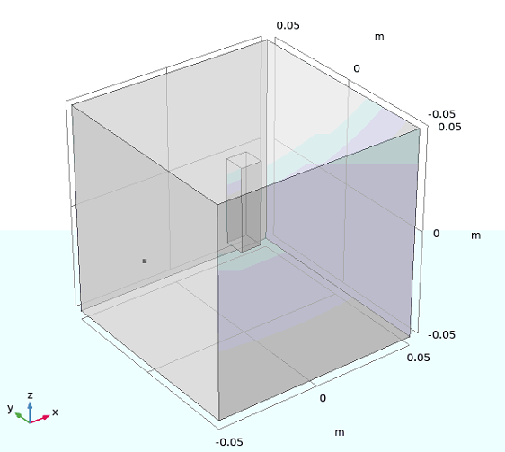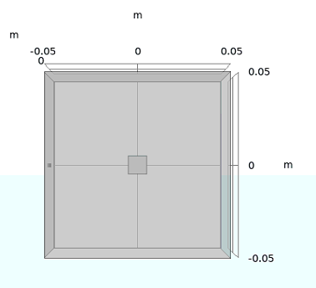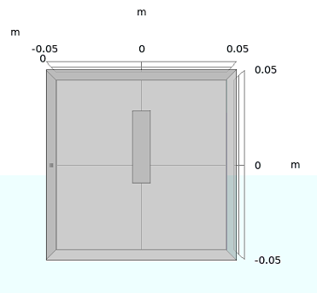

1.3 Solution Domains & Boundary Conditions

Both equations (1) and (2) are set to be solved in all domains (domain 1 and 2, corresponding to the block of air and the cuvette, respectively), since light entering through the point source is propagating through all the geometry. Flux/Source for Helmholtz equation (1) is defined as 0 and there is a second source (point source) defined at our third domain (which corresponds to the point previously set). The source for Helmholtz equation (2) is only solved for the cuvette (domain 2) and defined as $μ_{af}{ γ}_{m}{ φ}_{x}$ (the result from eq. (1) multiplied by the optical parameters to define the absorbed portion of the excitation light that propagates through air and hits the fluorescent material).

The dependent variables from equations (1) and (2) are defined as u and u2, respectively.

For the boundary conditions there is a pre-set Zero Flux 1 condition that states the fluence rate is zero at the selected boundaries. This is not correct since we should be also simulating reflections and other effects induced by the refractive index mismatch. A Robin-type boundary condition is used instead to model a realistic problem. After setting the correct parameters it looks like we have two boundary conditions on the left menu (both Zero Flux and Flux/Source), however if we check closely all the boundary selections for the Zero Flux are overridden (this means the other boundary condition is being assigned).

1.4 Mesh

The tetrahedral mesh chosen was set to be finer at the air-cuvette/dye boundaries and point source entry, with basic optimization levels (avoiding only inverted curved elements). Bigger maximum element sizes were set everywhere else (fine/normal, according to the pre-set COMSOL settings).

If we set the mesh too coarse the diffusion equation numerical solution is most likely wrong due to discretization errors; setting the mesh to be too fine everywhere will make the computation take too long (specially later with more studies and the parametric sweep function).

|  |  |  |  |
| --- | --- | --- | --- |
| Mesh Parameters | General Mesh | Free Tetrahedral 1  (point source) | Free Tetrahedral 2  (cuvette) |
| Maximum Element Size | 0.008 | 0.0055 | 0.0055 |
| Minimum Element Size | 0.001 | 4E-4 | 4E-4 |
| ME Growth rate | 1.45 | 1.4 | 1.4 |
| Curvature Factor | 0.5 | 0.4 | 0.4 |
| Resolution of NR | 0.6 | 0.7 | 0.7 |

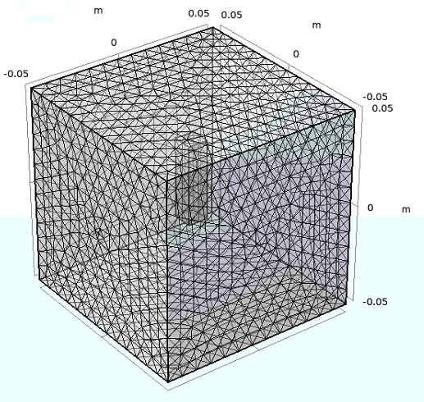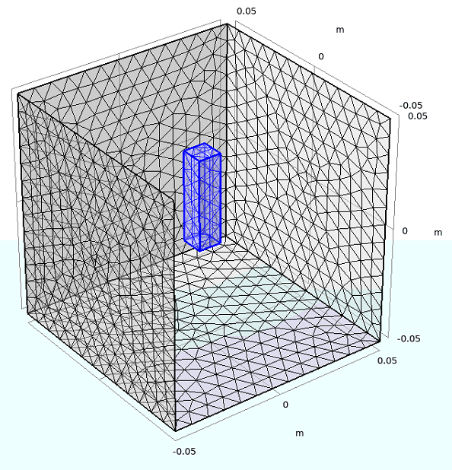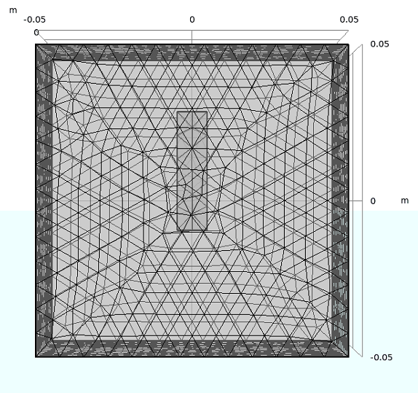

1.5 Results

Our final solution is contained in the variable u2 as defined by the Helmholtz equation (2).

2 Wavelength Dependance – parametric sweep